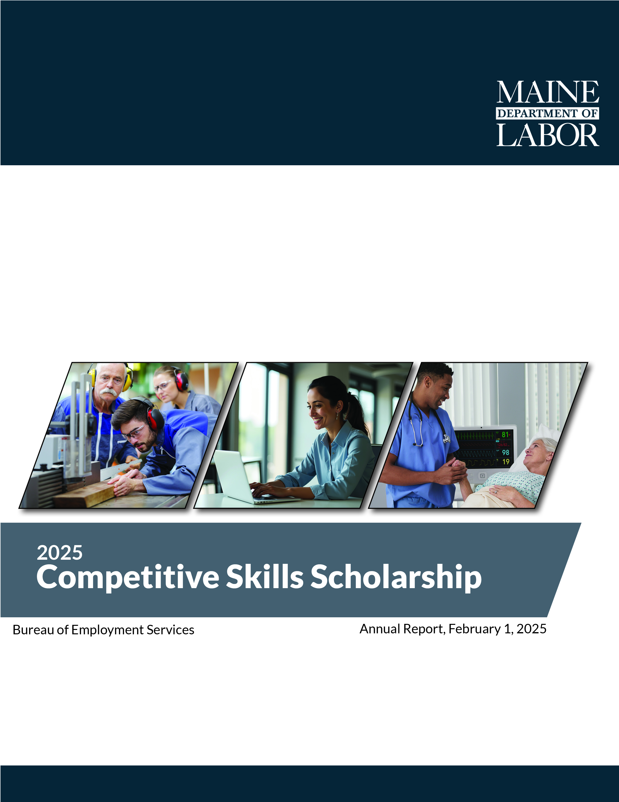

Contents

Executive Summary 3
2025 Program Outcomes 4
Improved Graduation Rates 4
CSSP Impact Study 5
Program Background 7
2025 Legislative Action & Statue Change 8
Who We Serve 9
Pursuit of High Wage, In Demand Careers 12
Partnerships 12
Financials 15
Plans for the Future 15

Executive Summary
The Competitive Skills Scholarship Program (CSSP) has made significant strides in 2025, achieving substantial milestones, improving the lives of low-income Mainers, and helping to grow our state’s talent pool as envisioned by Maine’s 10-Year Economic Development Strategy. It has enhanced opportunities for participants across the state, providing critical resources to help them access education, training, and ultimately high-wage, in-demand (HWID) jobs.
In 2025, CSSP helped 711 individuals pursue HWID careers essential to the growth of Maine’s economy. These individuals included those with limited income, as well those with barriers to employment such as being underemployed, having low literacy, limited English proficiency, or a disability.
Critical aspects of the program include support for childcare, transportation, books, supplies, and stipends that contribute to successful credential attainment and connection to good jobs. Legislation enacted in 2025 (§2033) allowed the Department to include more people in the program through cohorts and increased eligibility.
The program has shown remarkable success in improving graduation rates, with 75% of CSSP participants who graduated in 2024 earning a HWID degree or credential. When compared to overall graduation rates from Maine’s 2- and 4-year public institutions (average of 34% and 49%, respectively), the value of the program’s 1:1 career guidance and support is clear. CSSP’s ability to positively impact wages and employment outcomes is further demonstrated by the findings from an impact study by the Center for Workforce Research and Information (CWRI), which shows that completers since 2020 experienced a doubling of median earnings six months post-program and a significant increase in employment stability.
As CSSP looks ahead to 2026 under the newly created statute opportunities to strengthen collaboration with Maine’s education and training institutions to build programming for cohort-based learning, providing a collaborative approach to learning for students to advance together toward a common goal, leading to sustainable employment.
Maine currently has a tight labor market, and CSSP is an asset that helps employers connect with workers who have the necessary skills. Through continued collaboration with training and workforce development initiatives, CSSP will remain aligned with Maine’s economic development goals, supporting individuals as they pursue high-wage careers that meet the evolving needs of employers. Plans include improvements to the application process, strategic outreach efforts, and stronger connections with training programs.

Alex Britz-Cunningham

Alexander Britz-Cunningham recently graduated from NTI in Bangor with a certification in Heating, Ventilation, Air Conditioning, and Refrigeration (HVAC/R) after learning about the CSSP program through SNAP E/T. At the time of enrollment, Alexander was experiencing homelessness and facing significant personal challenges, including limited access to basic resources. From their first Zoom meeting, his CSSP caseworker provided clear guidance, patience, and consistent support, helping him understand the program and navigate the path forward during an especially difficult period in his life.
With a background in construction dating back to age 16 and a strong interest in heating and cooling systems, Alexander chose HVAC/R as a step toward a stable and meaningful career. Throughout the program, CSSP provided financial assistance, tools, equipment, and ongoing encouragement, allowing him to focus on his education and rebuild his life. Despite moments of frustration and setbacks, Alexander persevered with the continued support of his caseworker, ultimately achieving graduation and a renewed sense of purpose. His success reflects both his determination and the impact of compassionate, consistent support.

2025 Program Outcomes
CSSP served a total of 711 individuals in 2025. Of these individuals, 396 received a training stipend; 49 were students who participated in the High School Student Bridge program. CSSP enrolled 316 new individuals in 2025.

Improved Graduation Rates
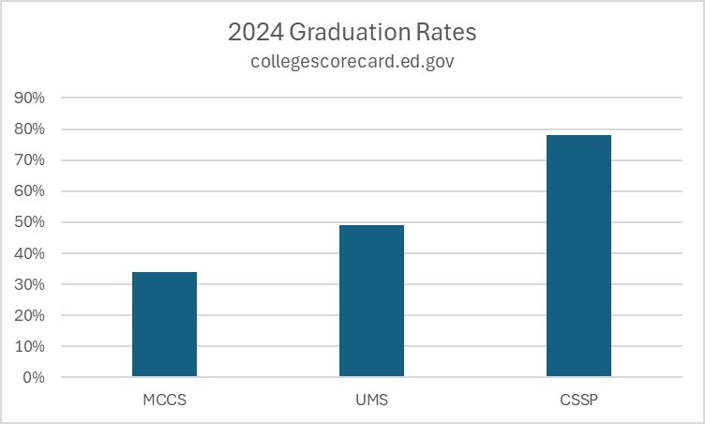
When students receive support from the CSSP program, they are significantly more likely to graduate than their peers without similar support. As captured by collegescorecard.ed.gov, 34% of students enrolled in Maine’s community colleges complete their degree within four years, and 49% of students in Maine’s four-year public colleges and universities complete their degree within six years. In contrast, 75% of students enrolled in CSSP who graduated in 2024 successfully obtained a degree or credential in a high-wage, in-demand field. This highlights the effectiveness of targeted supports, such as those provided by CSSP, in improving student outcomes and helping them succeed in their educational and career goals.

CSSP Impact Study
CSSP’s participant outcomes were evaluated by the Center for Workforce Research and Information (CWRI). The report analyzes outcomes for 673 participants who completed training between 2020 and 2025, comparing employment and earnings before enrollment and after completion using Maine unemployment insurance wage records, adjusted to 2024 dollars.

Participant Profile and Data Context
CSSP participants are predominantly female (63 percent), with the largest share under age 35. Outcome measures track employment and earnings across multiple years relative to enrollment, with “outcome year 1” representing the first full year after program completion. Because more recent completers have not yet accumulated sufficient post-exit data, later outcome years include fewer participants.
Employment and wage data reflect in-state covered employment only and exclude self-employment, independent contracting, and out-of-state work. All earnings figures are inflation-adjusted to 2024 dollars. To protect confidentiality, results are not reported for subgroups with fewer than ten participants.

Employment Outcomes
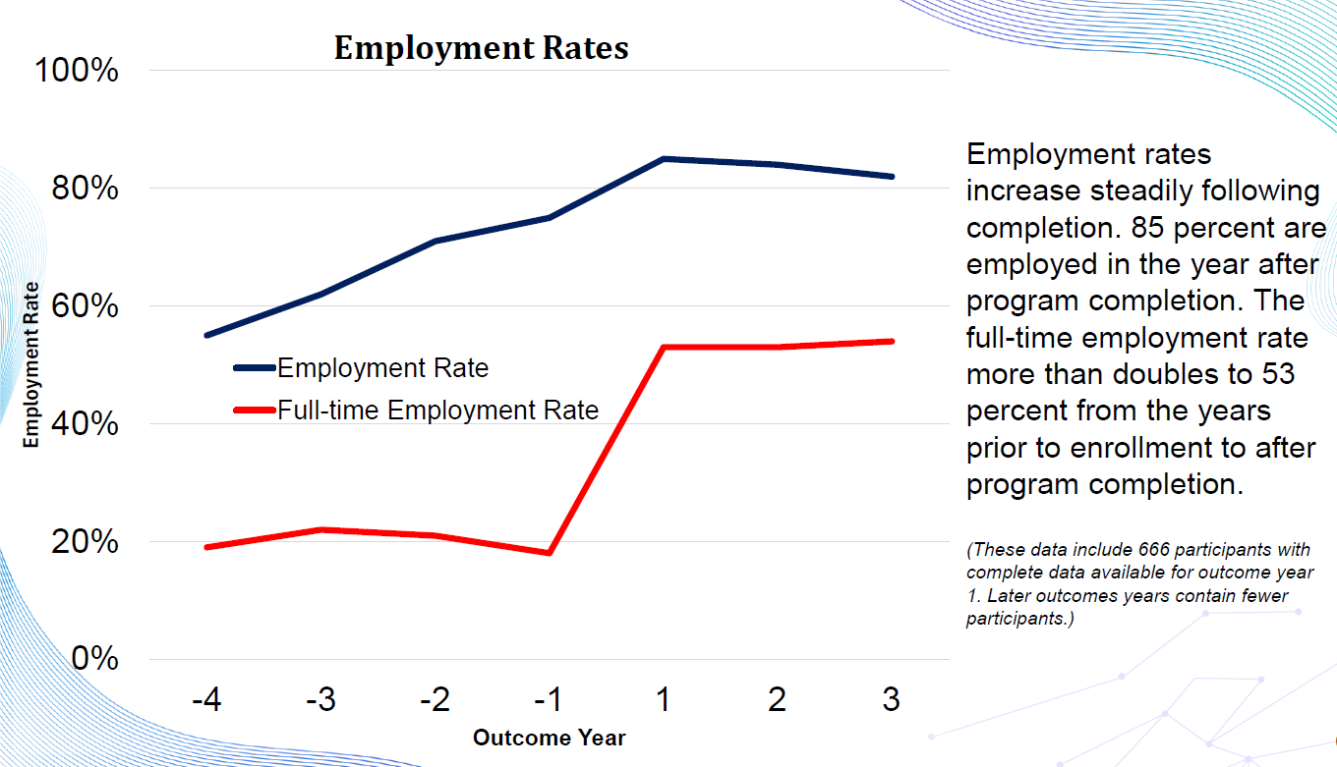
CSSP participation is associated with substantial gains in employment following completion of training. Employment rates rise steadily after exit, reaching 85 percent in the first year after completion. This represents a meaningful improvement over pre-enrollment employment levels and indicates that the program effectively supports participants’ attachment to the labor market.
Even more notable is the increase in full-time employment. Prior to enrollment, relatively few participants met the threshold for full-time equivalent work. After completing CSSP-supported training, the full-time employment rate more than doubles, reaching 53 percent in the year following program completion. This shift suggests not only increased access to jobs, but access to more stable and higher-quality employment.

Earnings Outcomes
Earnings outcomes show strong and consistent gains following program completion. Median annual earnings more than double compared to pre-enrollment levels, reaching approximately $45,000 per year in the first outcome year after completion. Among those working full time, median annual earnings increase by roughly $20,000, rising to approximately $60,000 per year.
Importantly, earnings gains are not limited to the middle of the distribution. Participants at the 25th percentile experience an increase of approximately $20,000 in annual earnings, reaching about $28,000 per year, while those at the 75th percentile see earnings rise by roughly $37,000 to over $70,000 annually. These results indicate that CSSP benefits participants across a wide range of prior earnings levels, supporting both income mobility and advancement into higher-paying roles.
As a result of rising employment rates and higher wages, aggregate earnings among CSSP completers increase dramatically. For participants with sufficient follow-up data, total annual earnings rise from approximately $6 million prior to enrollment to more than $16 million per year after completion, reflecting a substantial return in earned income to participants and the Maine economy.

Outcomes by Occupation
Post-completion earnings vary by occupational field, reflecting broader labor market wage patterns. The highest earnings are observed among participants entering skilled healthcare occupations, the trades (including construction, installation, maintenance, and transportation), and STEM-related fields. Within these categories, participants preparing for careers such as registered nursing, HVAC technician, electrician, and heavy or tractor-trailer truck driver report particularly strong earnings in the year after completion.
Lower earnings are observed among participants entering healthcare support roles, community and social services, and education-related occupations. While these fields generally pay less, participants in these pathways still experience earnings gains compared to their pre-enrollment outcomes, indicating that CSSP supports improved economic outcomes even in lower-wage sectors.

Outcomes by Demographic Group
Earnings gains following CSSP completion are broadly consistent across demographic groups. Median earnings increase at similar rates for male and female participants, though men earn approximately $7,000 more per year on average after completion. Full-time earnings trends mirror this pattern, suggesting that gender differences in earnings levels persist but do not widen as a result of program participation.
Age-related differences are more pronounced. Participants under age 25 have the lowest earnings prior to enrollment but experience the largest gains following completion, highlighting CSSP’s role in supporting early-career workers’ entry into higher-wage employment.
Participants who report having a disability earn less than those without a disability both before and after the program, but the magnitude of earnings growth is similar for both groups. This suggests that CSSP contributes to comparable proportional gains in earnings regardless of disability status.
By race, all reported groups experience earnings increases following completion. Black or African American participants have the highest median earnings after program completion among the groups reported, though smaller subgroup sizes limit more detailed comparisons.

Overall Assessment
Taken together, the findings indicate that the Competitive Skills Scholarship Program is strongly associated with improved employment stability, increased full-time work, and substantial earnings growth for participants. Gains are evident across demographic groups, earnings levels, and occupational pathways, with particularly strong outcomes in high-demand technical and healthcare fields. These results suggest that CSSP is an effective workforce investment that supports both individual economic mobility and broader labor market needs in Maine.
The full report is available https://www.maine.gov/labor/cwri/sites/maine.gov.labor.cwri/files/publications/2026-01/CSSP_Outcomes.pdf.

Shanealya Small
Shanealya Small immigrated to the United States from Jamaica with her family in pursuit of greater educational and life opportunities. During her junior year of high school at the Lewiston Regional Technical Center, she enrolled in the CSSP Bridge Program. This early access to college coursework played a pivotal role in shaping her academic journey.

After graduating high school, Shanealya was accepted to the University of New England (UNE). In the summer of 2025, after just two years, she completed her Bachelor of Science in Business Administration with no student loan debt. Her accelerated graduation was made possible thanks to the college credits she earned during her junior and senior years through the CSSP Bridge Program.
While at UNE, Shanealya immersed herself in campus life, taking on leadership roles that helped her grow both personally and professionally. She served as a Resident Advisor, a fellow in the Office of Community and Belonging, and a student ambassador in the undergraduate admissions office. In July 2025, Shanealya secured a full-time position as an Admissions Counselor at UNE, earning an annual salary of almost over $50,000. In this role, she supports prospective students through the recruitment and enrollment process —something that she is passionate about, having once stood in their shoes herself looking for guidance.
“The CSSP Bridge Program was truly life changing,” she said. “My case manager guided me through the complex process of planning for college, financially and supported me through every step of the way. Without the support of this scholarship program, I likely wouldn’t have been able to attend, let alone graduate from UNE. It helped me avoid student loan debt and gave me a strong foundation to succeed. Looking ahead, I plan to continue advancing my education by pursuing graduate studies an opportunity made even more accessible through UNE’s employee tuition benefits. I also have hopes to achieve personal goals like becoming financially independent, securing my own apartment, or even purchasing a car."

Program Background
Since 2007, CSSP has helped low-income Mainers attain the skills necessary to thrive in our state’s economy and help meet employer demand for a trained workforce. CSSP provides post-secondary education; training for degrees and industry-recognized credentials including those gained through Registered Apprenticeships; and other essential supports that support participants’ entry into high-wage, in-demand jobs in Maine. The program increases an individual’s ability to fully participate in Maine’s workforce, to earn family-supporting wages, and to contribute more robustly to Maine’s economy by encouraging lifelong learning and credential attainment. CSSP is funded through a small (.34%) assessment on Maine employers who contribute to the Unemployment Insurance Trust Fund. An employer’s unemployment tax is reduced by the amount paid into CSSP, as required by Title 26 §1221 sub-§4-A of Maine statute. With Maine’s tight labor market, we need everyone to have the opportunity to achieve their full potential – an economy where workers can have good jobs and employers can prosper.
The investment in CSSP participants to gain the skills needed to obtain good-paying and sustainable jobs will help reduce recurring need for and dependency on unemployment compensation and similar benefit programs.

2025 Legislative Action & Statue Change

Summary of Statutory Changes (PL 2023, c. 184 (LD 1956)
During the 132nd session, the legislature passed into public law LD 1956 - an Act to Amend the Law Governing the Competitive Skills Scholarship Program and Establish the Community Workforce Connections Program.
Key changes include an increase in the income eligibility threshold for CSSP from 200% to 275% of the federal poverty level (FPL) for the applicable household size. This change was made in response to rising wages and living costs, which had resulted in approximately 15% of applicants in 2024 being denied due to income slightly exceeding prior limits. The new threshold aligns more closely with comparable programs, such as the HOPE program.
The law also authorizes the approval of cohort-based education and training programs, extending eligibility to individuals participating in these structured group programs.
In addition, the statute establishes clearer application and decision timelines. Applicants must receive a written eligibility decision within 30 days of application receipt. This deadline may be extended by 15 days at the applicant’s request to provide additional information or further extended when required third-party information is not available, with the department providing assistance in obtaining such information.
Finally, the law clarifies retroactive service provision, requiring eligible services, such as tuition, books, fees, stipends, childcare, and transportation to be provided retroactively to the date of application or demonstrated need, as applicable, to support successful program participation.
Gatlet Karam

Originally from Sudan, Gatlet Karam became a permanent U.S. resident in June 2014. He began his nursing training at Walla Walla University where he obtained 18 credits, then Southern Adventist University for another 24, until he could no longer afford the tuition. He then applied and was accepted to USM in 2019. When he applied for CSSP he was living with his brother and making $12.76 an hour as a part-time cashier at Hannaford. He was able to obtain a position at Maine Health and increased his wages to $20.87 per hour during his enrollment. Gatlet received assistance from CSSP in the form of a new computer, tuition, books, and fees.
Gatlet completed his nursing program in December 2024 with an overall GPA of 3.604. He passed his NCLEX exam on February 5, 2025, and accepted employment at Maine Medical Center as a full-time Emergency Room Nurse making $35.74 per hour. From the time of initial enrollment to completion, Gatlet was able to increase his weekly wages by 404%, or $1,031.44 per week.

Who We Serve
2025 participants in the CSSP program reside in all 16 counties of Maine. CSSP serves a wide range of participants, with a focus on helping individuals at various stages of their careers and educational journeys. The age distribution from 16-70 at enrollment shows a broad representation, particularly among adults in the workforce. The average age among participants in 2025 is 35 years old.
The program’s age distribution demonstrates the need for CSSP to individuals across a wide age spectrum, offering career advancement and educational opportunities to those at various stages of life and professional development.
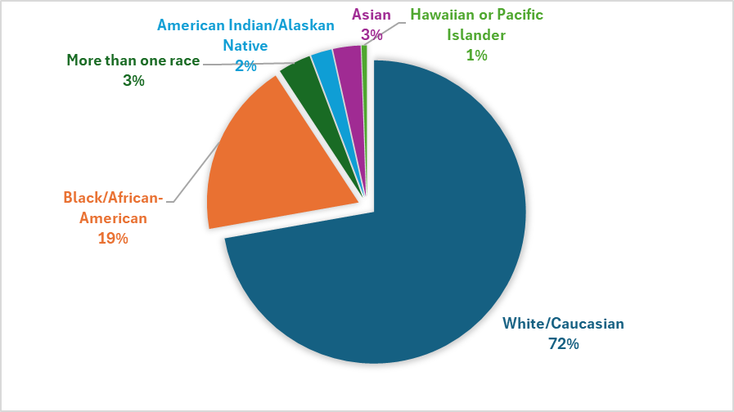

Those served by CSSP included:
- 73% white/Caucasian
- 19% Black/African American
- 5% Hispanic or Latino
- 62% female
- 38% male

Identified Barriers to Employment
Participants of CSSP face a range of challenges that reflect the varied and complex barriers to success they encounter. These challenges can significantly impact an individual’s ability to access education, secure stable employment, and advance in their careers.
The following highlights some of the key barriers faced by CSSP participants:

- 114 individuals report being “basic skills” deficient
- 113 individuals identify as having a disability
- 81 individuals have a criminal background
- 26 individuals report experiencing homelessness
- 59 individuals face limited English proficiency
- 225 individuals report being long-term unemployed
- 100 individuals have previously dropped out of high school
- 165 individuals are single parents
- 115 individuals report a history of substance abuse

Employer: ME-RAP

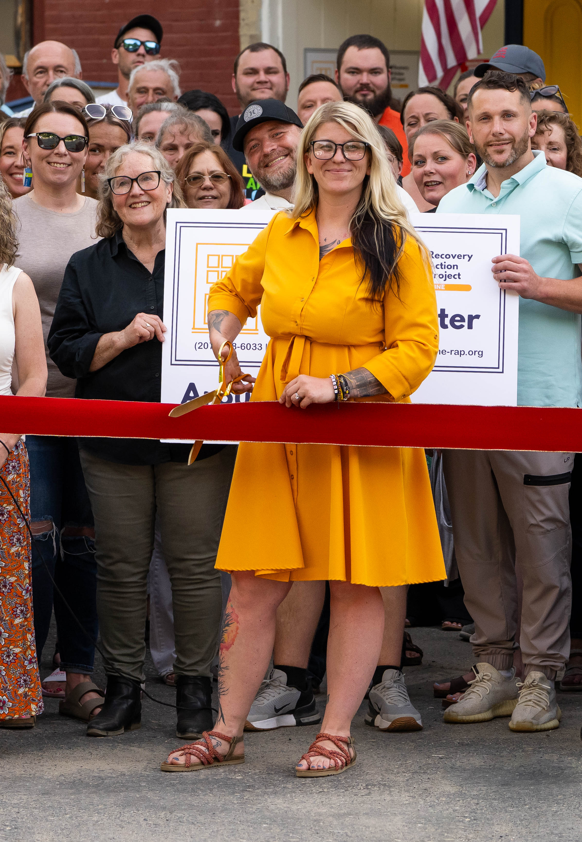
Courtney Gary-Allen, the Executive Director of the Maine Recovery Action Project and the Maine Recovery Access Project, sister organizations collectively known as ME-RAP, has benefited from CSSP both as a graduate and an employer.

At 16, she earned her GED while caring for a young child, later completing her bachelor's degree at the University of Maine at Augusta in 2020, with the support of the CSSP program throughout her undergrad. She went on to earn a master's degree at the Muskie School of Public Service in 2025, as well as complete her first year of law school.
“When I was an undergrad, I was a TANF recipient and I got involved with vocational rehabilitation (VR), and then VR got me involved with CSSP,” she said. “The support that I received from the triangulation of all of those programs together, I wouldn’t be who I am, I wouldn’t have an undergrad, and I definitely wouldn’t be the executive director of a nonprofit.”
Now as an employer, she is in a position to be looking for skilled individuals to expand her workforce. She ended up hiring Courtney Meade, not realizing that this Courtney was also a CSSP graduate until later.
“It makes a lot of sense to me, as both an employer and a graduate of the program, that someone as phenomenal as Courtney would have gone through CSSP in her undergrad,” she said. “We’re really grateful that Courtney is getting to join our team with the skillset she has and helping to expand the capacity to support Maine’s recovery infrastructure.”
“Both as an employer and a graduate of the program, (CSSP) is a wonderful program that helps to invest in our leadership and people in Maine, both to provide employees to organizations that so desperately need them across the state, but also to invest in individuals so that they can move forward in their lives,” she said. “This is a great investment of our taxes into the employment infrastructure in Maine.”
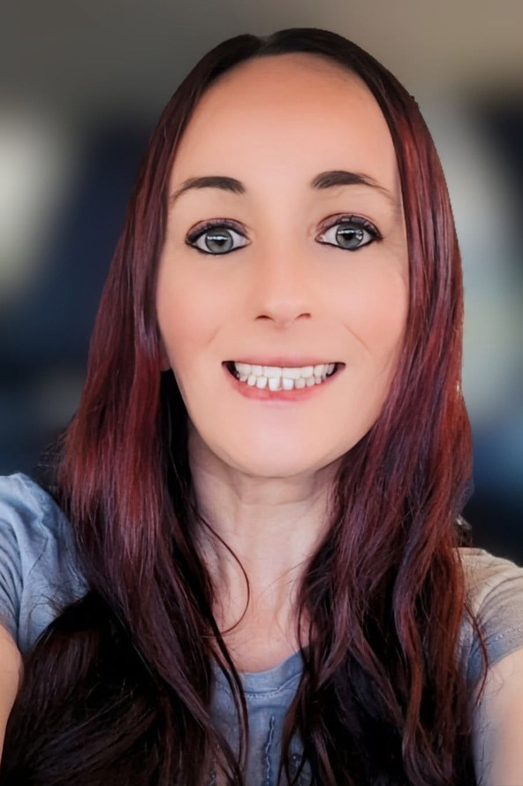
Courtney Meade
Courtney is in long-term recovery and has worked tirelessly to rebuild her life and create a meaningful future for herself and her family. She was accepted into the University of Maine at Augusta’s online Mental Health Rehabilitation Technician/Community Certificate program, which allowed her to balance education, work, and parenting. Her long-term goal is to become an addiction counselor and support others on their recovery journeys.
When Courtney applied for assistance through the Competitive Skills Scholarship Program (CSSP) she was receiving Supplemental Nutrition Assistance Program (SNAP) benefits and had applied for additional support through the Higher Opportunities for Pathways to Employment (HOPE) program. Like many individuals in recovery, Courtney was managing significant financial and personal challenges while trying to move forward.
Courtney’s employment history included work as a bank teller and loan officer, and more recently as a server. She initially began working remotely as a part-time student loan counselor, earning $18.00 per hour while completing her education. Since then, her dedication and leadership have led to even greater opportunities. Courtney first joined Maine Recovery Action Project (Me-RAP) as a statewide volunteer organizer in 2024 and expanded her role as an intern focused on opioid settlement fund transparency, accountability, and public engagement. In November 2024, she was hired as Me-RAP’s Organizing Coordinator, earning $22.00 per hour in a full-time, primarily remote position.
CSSP played a critical role in addressing a major barrier to Courtney’s well-being. Due to severe dental issues, she was struggling to eat and live without pain. With support from CSSP and the Build Hope Program, Courtney was able to obtain a full set of dentures, which had a significant impact on her confidence and appearance - in turn supporting her ability to obtain employment.
Courtney shared that her confidence has increased “a million” times, and she is no longer living in pain. “I didn't believe in myself, but knowing I had support to at least try changed my outlook,” she said.
Courtney has come so far emotionally, professionally, and personally. She has built stability, leadership, and a clear path toward a career helping others.
Her story is a powerful example of how targeted support, education, and opportunity can help individuals not only overcome barriers, but thrive and give back to their communities.

Pursuit of High Wage, In Demand Careers
As shown in the chart below, the 2025 participants are working toward careers as Registered Nurses, Counselors and Social Workers, and Teachers. The program also reflects significant interest from aspiring Engineers, Accountants, Biologists, IT Specialists, Managers, Electricians, Chefs, and CDL Drivers.

Partnerships
CSSP is dedicated to building strong internal and external partnerships to enhance support for our participants. Through co-enrollment, participants can access coordinated, wraparound services that address both training and basic needs, reducing barriers to program completion and improving employment outcomes. By braiding resources from programs such as SNAP E&T and HOPE, CSSP maximizes federal and state investments, avoids service duplication, and leverages cost-sharing arrangements to increase program efficiency. This integrated approach strengthens workforce pipelines, supports family economic stability, and delivers a higher return on investment for participants and the state alike.
When participants lack sufficient financial resources to enroll in or complete a training program, CSSP case managers actively work with partner programs to identify additional support options. They coordinate with workforce and training partners—including Workforce Innovation and Opportunity Act (WIOA), Vocational Rehabilitation (VR), Higher Opportunity for Pathways to Employment (HOPE), and SNAP Employment & Training (SNAP E&T)—to pursue co-enrollment opportunities, allowing participants to combine resources and access the full spectrum of supports needed for success.
Through these partnerships, participants may receive supplemental funding for tuition exceeding CSSP limits, as well as supportive services such as mileage reimbursement or public transportation assistance. When co-enrolled with Vocational Rehabilitation (VR), case managers collaborate closely with VR staff to assess individual needs and determine whether braided funding from both programs is appropriate to support the participant’s training plan. Similarly, participants receiving SNAP benefits may co-enroll in SNAP E&T to address additional financial or supportive service needs.
This collaborative, coordinated approach ensures participants have the resources necessary to fully engage in training, while maximizing partner funding and minimizing barriers to completion.
CSSP partners with key programs to ensure participants receive comprehensive and effective support, including:

Pre-Apprenticeship/ Apprenticeship
During this program year, twelve eligible Pre-Apprentices applied for support through CSSP, each bringing diverse backgrounds, experiences, and goals. While their pathways varied, the outcomes demonstrate the value of early engagement, individualized planning, and strong collaboration.
As part of the intake process, four individuals completed credential evaluations, or, after gathering the necessary documentation, confirmed that their out-of-country degrees were equivalent to at least a U.S. bachelor’s degree. These evaluations helped participants better understand their existing qualifications and help them identify appropriate next steps toward employment or training. Eight applicants attended pre-apprenticeship instruction.
Of those participants:
- Two successfully transitioned from pre-apprenticeship into registered apprenticeship programs.
- Four moved from pre-apprenticeship into two- or four-year training programs aligned with their career goals.
- One participant attended pre-apprenticeship and is currently pending a final decision regarding next steps.
- One individual attended two separate pre-apprenticeships but ultimately chose not to pursue an apprenticeship or training program and was exited from CSSP.
Overall, these results highlight that success does not follow a single path. Participants come to the table with different skills, educational backgrounds, life circumstances, and levels of readiness, and not all ultimately meet eligibility or select a training route. These groups reinforced meaningful preparation, clear communication, and collaboration among partners are essential to helping individuals identify realistic and sustainable career pathways.
While not every applicant moved forward in the same way, the groups produced strong outcomes, informed future improvements, and strengthened our approach to supporting participants as they navigate education, training, and employment opportunities.

Supplemental Nutrition Assistance Program (SNAP) Employment and Training (E&T) Program
The SNAP E&T program in Maine helps recipients of SNAP benefits secure and maintain employment through job training, education, and support services. In the past year, 50 individuals were co-enrolled in both the SNAP E&T program and CSSP to better address their specific training and employment needs. Notably, the Department of Health and Human Services Office of Family Independence reimburses the Department of Labor’s Bureau of Employment Services (BES) for 50% of eligible expenses incurred by BES Case Managers while delivering services under a Memorandum of Understanding. This includes funding for a 0.75 FTE Case Manager position with benefits.

Higher Opportunity for Pathways to Employment (HOPE) Program
The HOPE program provides financial assistance to parents and families in Maine, helping them access education and training beyond high school. Administered by the Maine Department of Health and Human Services (DHHS), 50 individuals were co-enrolled in both the HOPE program and CSSP, ensuring they received the support needed to achieve their career goals.

WIOA
The WIOA Program offers financial assistance to job seekers and is administered by local area workforce boards. A total of 126 individuals were co-enrolled in WIOA and CSSP, receiving coordinated support to successfully pursue their employment and training objectives. Notably CDL and HVAC trainees tend to benefit from this dual enrollment to achieve their short-term credentials.

Peer Workforce Navigator Project
The Peer Workforce Navigator Project helps to recruit new participants through community-based organizations. In collaboration with the Peer Workforce Navigator Project, CSSP has worked to identify potential candidates, uncovered barriers in the application process, and is now taking action on opportunities for program improvement. This partnership enhances CSSP's ability to serve participants effectively and address challenges in workforce development.
Building on this successful collaboration, expanding the program will require targeted statutory changes to establish and support the Community Workforce Connections Program (Statutory Changes, Sec. 12, 26 MRSA § 2066). The Community Workforce Connections Program establishes a statewide initiative, to be implemented by January 1, 2026, that provides peer-led workforce navigation and support to unemployed and underemployed individuals, with priority populations facing significant barriers to employment. Through contracts with trusted community-based organizations, the program delivers culturally appropriate, strengths-based, and relationship-focused services that help individuals access education, training, employment services, and public benefits, while supporting their transition to sustainable employment and greater economic security.
The program will use peer navigators with shared lived experience to proactively engage individuals, connect them to Maine Department of Labor career centers and workforce partners, assist with applications and eligibility processes. The program will enhance outreach to communities with low participation in unemployment insurance and reemployment services, offering hands-on assistance with claims, education about available benefits, and coaching to overcome barriers.
Eligible entities must demonstrate trusted relationships with priority populations, have expertise in workforce and benefit systems, protect participant confidentiality, and provide services at no cost. The Commissioner of Labor may award multiple, multi-year contracts, prioritizing organizations with strong community leadership and ensuring services supplement—not replace—existing Department of Labor services. At least 12% of the annual planned yield of the Competitive Skills Scholarship Fund must be dedicated to the program, with unspent funds returned to the fund, and the Commissioner is required to submit a comprehensive financial report to the Legislature by November 1, 2026.
MDOL published a request for applications seeking qualified entities in December 2025 and will work towards implementation in the year ahead with the selected vendor.

Financials
CSSP expenditures in calendar year 2025 were just over $4,853,000. Over the past few years, with many college and training programs available at no cost with Maine Jobs and Recovery Plan funds, CSSP was able to leverage training costs from other sources in 2024. Because of this cost-sharing, the ratio of case management, which is crucial to participant success and retention, was higher from prior years. Information on how much the other programs contributed is not available, as not all are administered by the Department.

Average Annual Cost Per CSSP Participant
Category | ALL CSSP
Number of Trainees Served in 2025 | 711
Training Expenses (tuition/books/fees/equipment) | $ 1,323,165
Stipends and Supports (mileage, repairs, childcare, etc.) | $ 1,814,642
Participant case management, career planning, payment processing, etc. | $1,167,330.19
Administration and Management | $413,104.85
Community Connector | $134,788.46
TOTAL 2024 Expenses | $4,853,030.83
Average Annual Cost Per Person | $6,825.64

Plans for the Future
In 2026, the CSSP team is committed to rolling out a series of significant system improvements and fostering new partnerships aimed at enhancing the overall experience for applicants, training providers, and employers. In early 2026 the new application process will be launched. The new application process will leverage the existing case management system, Maine JobLink, to limit processing delays and duplicative data entry for the benefit of the applicants to comply with the new statue.
In the year ahead, CSSP will be working with community partners to modify rules as related to the new statue. A listening session is scheduled for February 10th, 2026. New rules may go into effect as early as June 20th, 2026.
Alongside this, CSSP will continue to strengthen its connection with training programs connected to high wage-in demand jobs and enhance the referral process. Through this alignment, the team hopes to attract a greater number of eligible applicants who are well-prepared and motivated to engage with CSSP’s offerings. Furthermore, outreach efforts will be more strategic and intentional, targeting locations where qualified individuals are located. These combined efforts are designed to ensure that the CSSP program is more efficient, accessible to all, and a continued benefit to Maine’s workers and employers.
The Maine Department of Labor provides equal opportunity in employment and programs.
Auxiliary aids and services are available to individuals with disabilities upon request.

